CPT 208 Group Project

Coursework/Assignment Submission Form

2020/21 Semester 2

Bachelor’s degree – Year 3

|  |  |  |
| --- | --- | --- |
| Module Code | Module Leader | Module Title |
| **CPT208** | **Lingyun Yu** | **Human-Centric Computing** |

**Section A: Your Details**

*To be completed by the students (in English using BLOCK CAPITALS)*

|  |  |
| --- | --- |
| Student ID | Name |
| 1823832 | Lihan Zhao |
| 1824150 | Xingbo Wei |
| 1824142 | Zhichao Ma |
| 1824140 | Hening Fan |
| 1824152 | Tianlei Shi |

**Section B: Assignment Details**

*To be completed by the students (in English using BLOCK CAPITALS)*

|  |  |
| --- | --- |
| Coursework Assignment Number | **Group report (Evaluation)** |
| Coursework (assignment) Title | **Group 38_Evaluation Report** |
| Method of Working | **Group** |
| Date and time of submission |  |

*Assignment details can be found in the assignment description.*

**Section C: Statement of Academic Honesty**

*To be completed by the students*

By submitting this coursework for assessment, you are confirming that you have read and understood the University’s policy on plagiarism and collusion and that the submitted work is your own.

1. We confirm that we have read a copy of the current University’s definitions of collusion and plagiarism on coursework and academic honesty, and that we fully understand the meaning of these terms.
2. We confirm that the submitted coursework has been created solely by our group and that we have not been assisted, nor have copied part or all of somebody else’s work, either with their explicit approval or without their knowledge or consent.
3. We confirm that this is our own work and that use of material from other sources, including the Internet, has been properly and fully acknowledged and referenced.
4. We confirm that the information we have given is correct to the best of our knowledge.

|  |  |  |  |
| --- | --- | --- | --- |
| Student’s signature | Lihan Zhao Xingbo Wei Zhichao Ma  Hening Fan Tianlei Shi | Date |  |

*If this form is submitted electronically, please type your name in English (BLOCK CAPTIALS)*

Group 38_Evaluation Report

**1. Introduction**

As products and applications are designed with the aim of serving the customers better. Human-centric design principles (DP) [1], several heuristic principles of design, are widely used in development. However, there are several DP-violating functions exists in some popular products yet, which greatly ruined the user experience. Therefore, this report chosen two products which are applied universally, and analyzed what and how the DPs were violated in detail. What’s more, two questionnaires were released to solicit opinions from users for assist in analysis.

**1.1 Introduction of Learning Mall**

Learning Mall (LM) is an online assist course website that developed by XJTLU, which can supply a wide range of learning materials and didactical supports for students. Three functions will be discussed in this report, including the login interface, “MyCourse” button and the file-uploading function. Those functions are unfriendly to users and be found exist the design problem of DP-violating.

**1.2 Introduction of NetEase Cloud Music**

NetEase Cloud Music (NEC-music) is currently one of the most extensively used music applications. Music applications should always aim at providing smooth and comfortable user experience for their customers. However, several designs in NEC-music are still noticed to be unsatisfactory, which consists of the miscellaneous unrelated functions together with the problems taken place when using the private FM function and the private song list function.

**2. User Evaluation**

To increase the universality and objectivity of analysis, this report designed and released two questionnaires [2] for both applications. A total of 64 people participated in the questionnaire on LM, meanwhile the survey of NEC-music is conducted by 95 people (as of 14 Apr.). The following evaluations will be presented according to the results of questionnaires.

**2.1 User Evaluation of Learning Mall**

**2.1.1 User Evaluation of Login interface**

Most of LM-users are students, and they may close and re-enter LM after once login. When user re-entering, LM will in Home-page, and still shows a “log in” button as shown below.



Fig.1. LM still shows “log in” button even if user already logged

However, it will show “You are already logged in” when user click “log in” button. Based the questionnaire’s collected feedback, 89.06% people who joined in the survey have met the situation. This makes users really confused, and they may click “log out” button and re-login. But the correct way is to click the blue button in upper-right, find “Dashboard” button, and click it.

A lot of students don’t know there a blue button, and this function make many inconvenient for users. Users want more convenient and clear products.

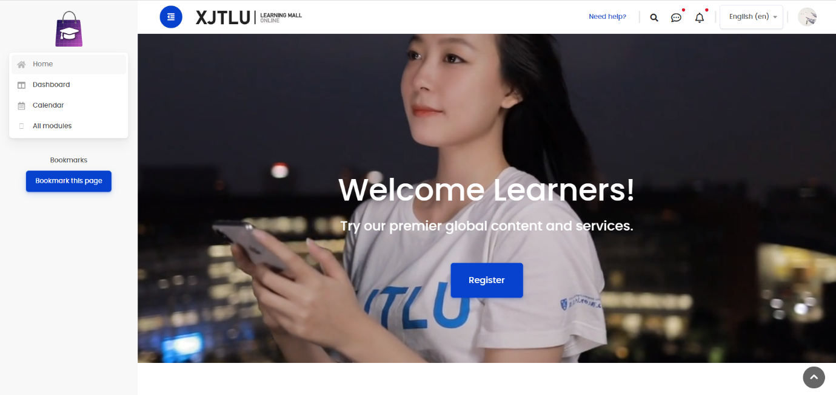Fig.2. Blue button is not on prominent position

**2.1.2 User Evaluation of MyCourse Button**

Students usually use jump button to make LM jump to other modules. But some jump button is an imaginary button. Such as the “my course” button.



Fig.3. Imaginary button “My course”

This button cannot be click, and cannot jump to other modules. According to our data, 78.13% people who have found this design quite unfriendly. This makes users unexpected, because they think a button should be work.

**2.1.3 User Evaluation of File-uploading Function**

When user submitting files to LM, it doesn’t provide a prompt whether the submitting period had finished. While large files are uploaded, the progress of files’ transferring is invisible. Thus, waiting in the web page seems to be only choice, which is Irrational. It is interesting that although the people who have uploaded big files only occupy a half (43.75%), but nearly all of them (85.71%) want LM to provide feedback when uploading.

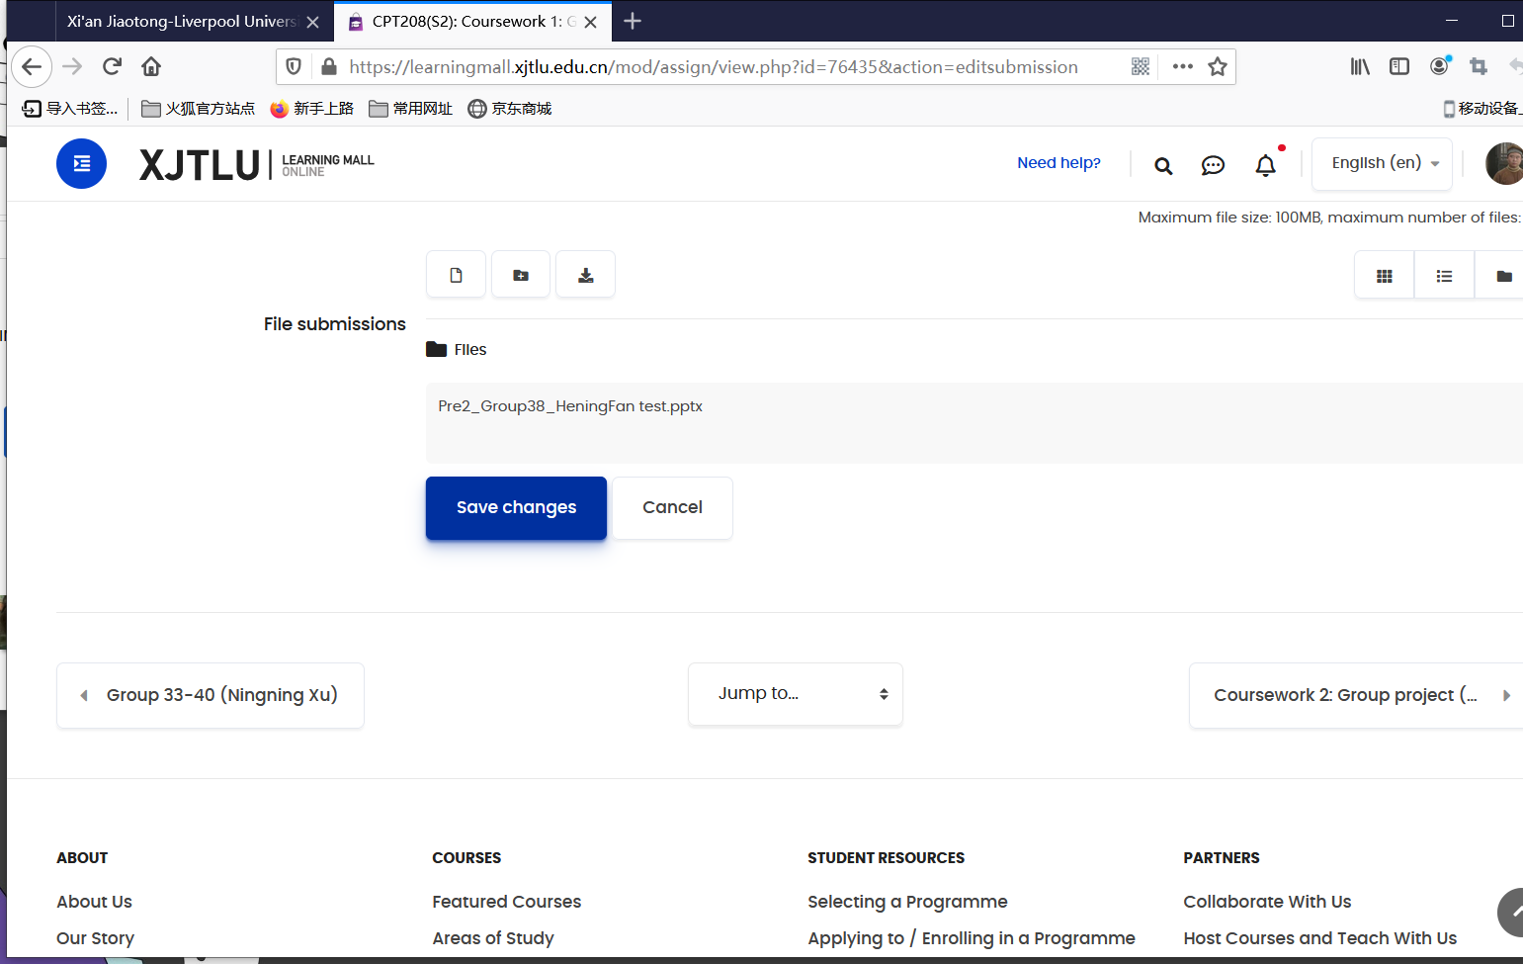

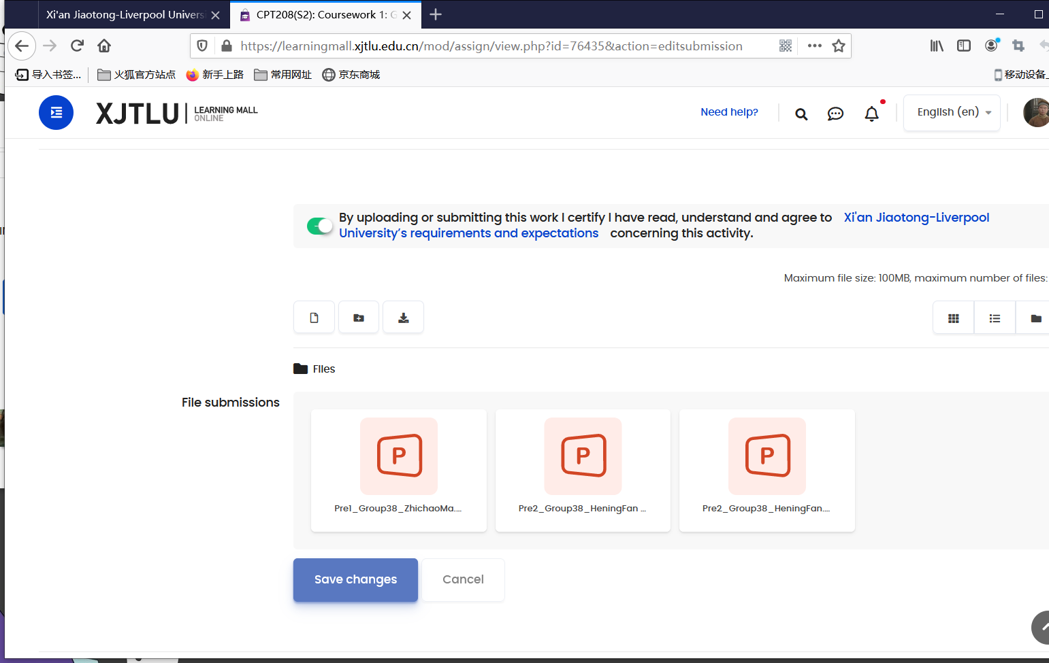

Fig.4. LM do not provide feedback when uploading

* 1. **User Evaluation of NetEase Cloud Music**

**2.2.1 User Evaluation of Miscellaneous Unrelated Functions**

It is found that listening to music and watching songs’ comments are the main functions, those experience are concerned by the users more significantly. Among people that conduct the survey, 69.74% of them have shown their opinion that unrelated functions like live broadcasts or games influenced their listening experience. Music applications should pay more attention to the functions that can provide comfortable service for listening to songs.

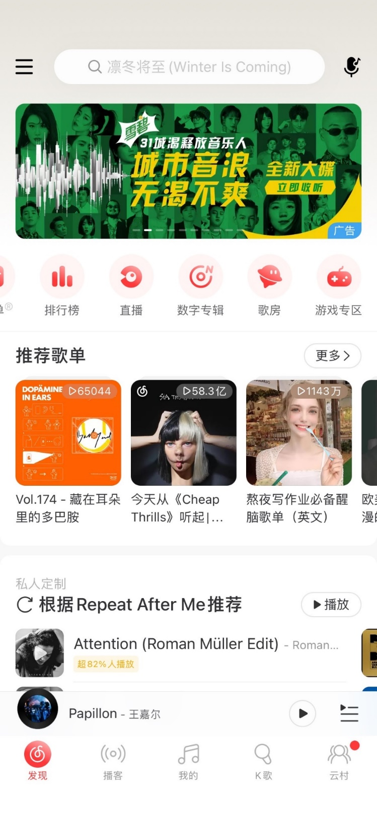

Fig.5. Home page of NEC-music exists many unrelated functions

**2.2.2 User Evaluation of Private FM Function**

Private FM function of NEC-music can push users completely new but same kind songs by analyzing the users’ favorite kinds of songs. However, three quarters of people who have used the private FM function have found that it is impossible to switch to previous song. It’s violates user expectations, because they generally want to find good music they have listened before.

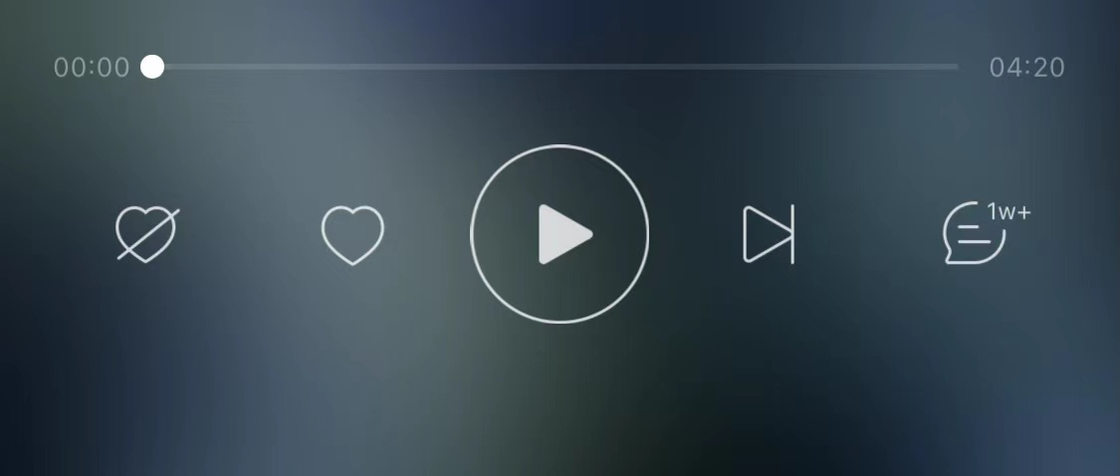

Fig.6. Private FM function of NEC-music cannot switch to previous songs

**2.2.3 User Evaluation of Private Song List Function**

As the privacy is a personal matter that people are unwilling to tell others or be interfered, meanwhile some songs are in the category of people’s personal privacy as well due to some personal factors. At this point some customers are likely to transfer some specific song lists from public state to private state. However, this application does not provide such function and it only allow users to create a new song list in private state primitively. Users can turn a private list to public state, but no function for changing it back. However, according to the collected data, only 38.6% people have found this problem, but all the them want a song list can be switched between the two modes freely.

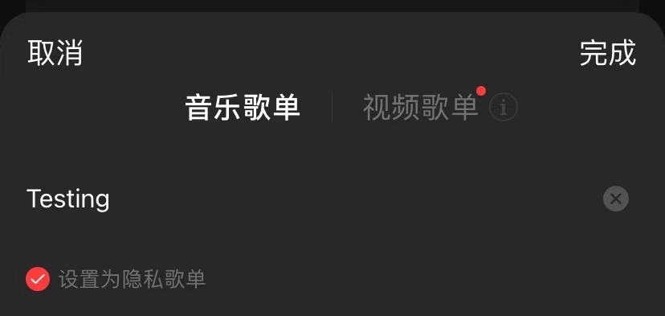

Fig.7. Song list can be created with private state

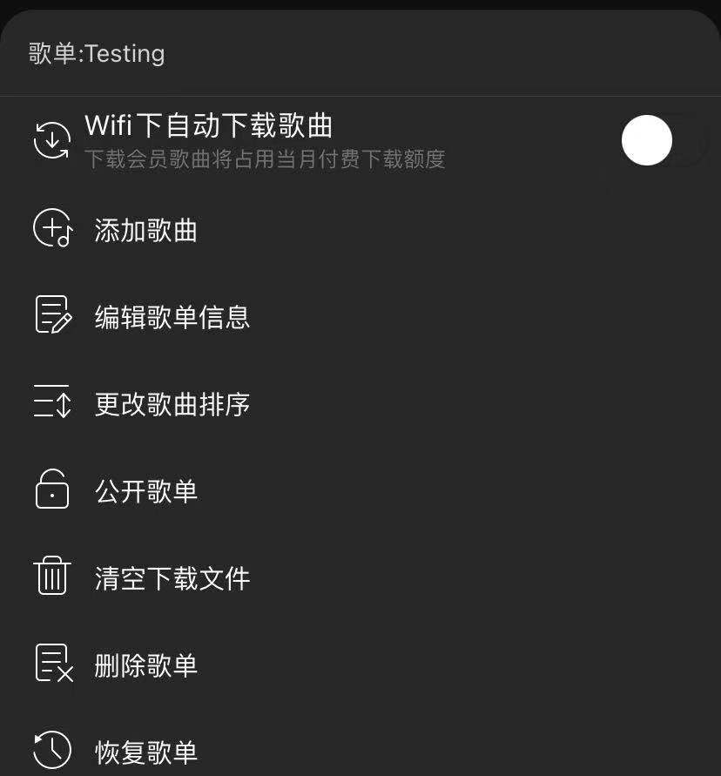 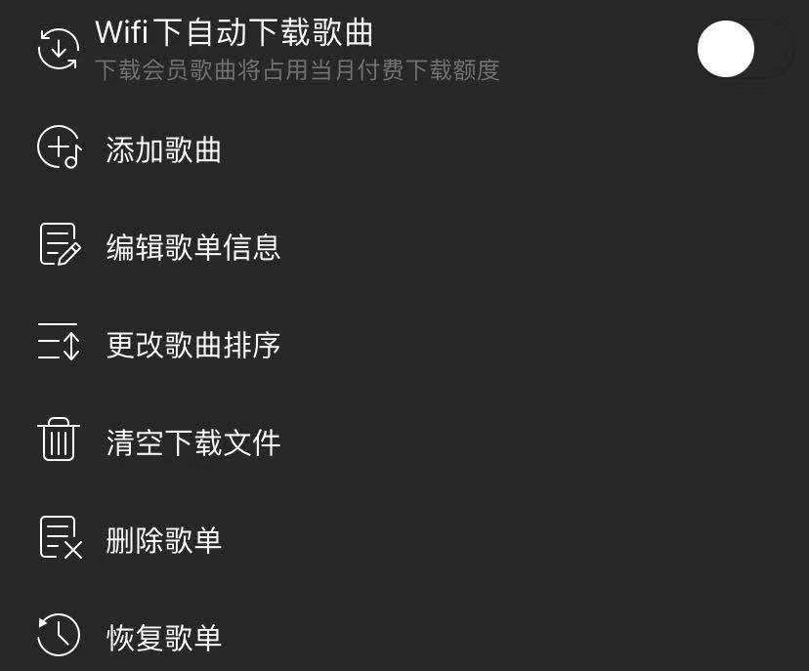

Fig.8. Private song list can be made public, but public song list cannot be made private

**3. Discussion**

**3.1 Discussion on Learning Mall**

**3.1.1 Login interface**

The DP of “Let the User Develop a Mental Model” [3] means that design cannot against the habits and common sense of users. It is a well-known specification that the opposite of log-in should be log-out. However, LM still shows “log in” button even though users have logged in, which against the common sense of human. This idea is supported by 92.98% of the surveyed user. So, this is the first DP be violated.

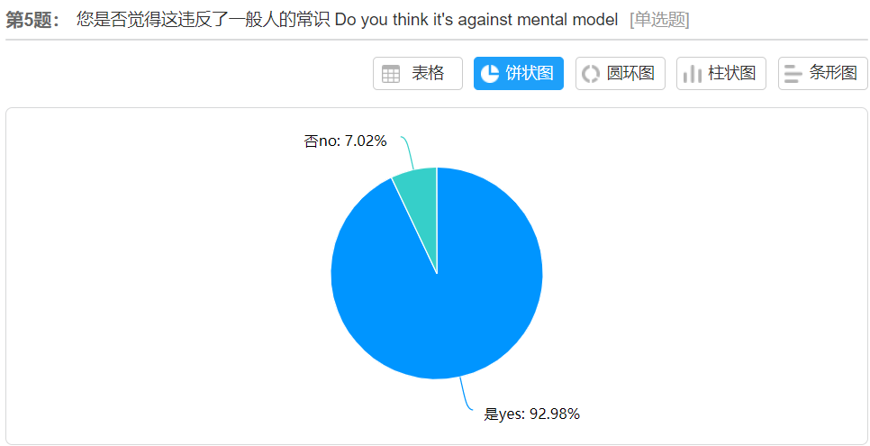

Fig.9. 92.98% surveyed user agree login interface against common sense

Nevertheless, DP of “Simple and Natural Dialog" [3] means product should shows information that users needed rather than unrelated information. LM should show the most important information to users instead of showing beautiful but useless pictures and hide key button. This idea approved by 84.21% of people. Consequently, is the second DP that be violated.

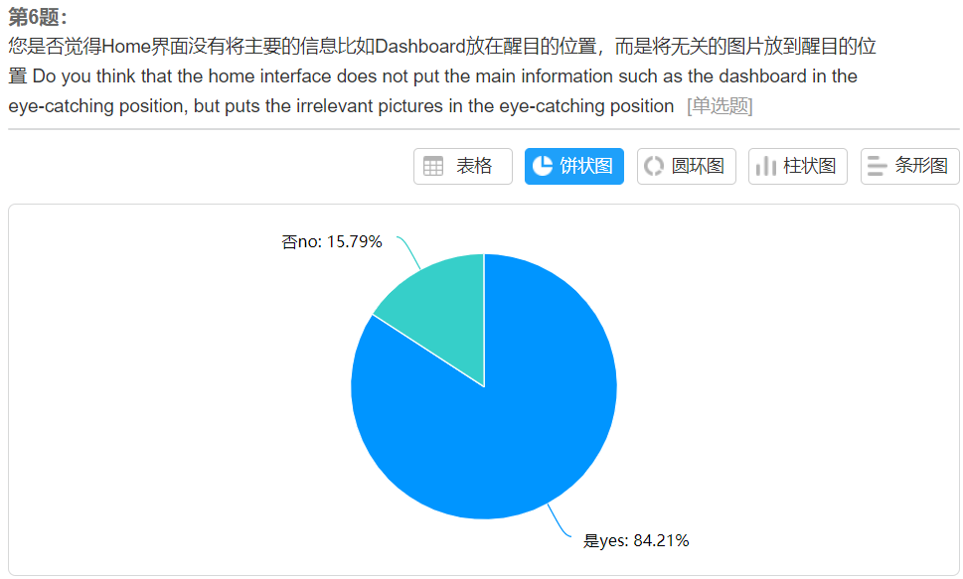

Fig.10. 84.21% surveyed user agree login interface shows too much irrelevant information

**3.1.2 Imaginary Button**

What’s more, the imaginary button is obviously violating the design principle of “Simple and Natural Dialog, Let the User Develop a Mental Model” with 94% participants agree with the idea. Because this is a predecessor path, if this path not exist, the path that user now in should not exist either. However, this logic is broken by this “my course” button.

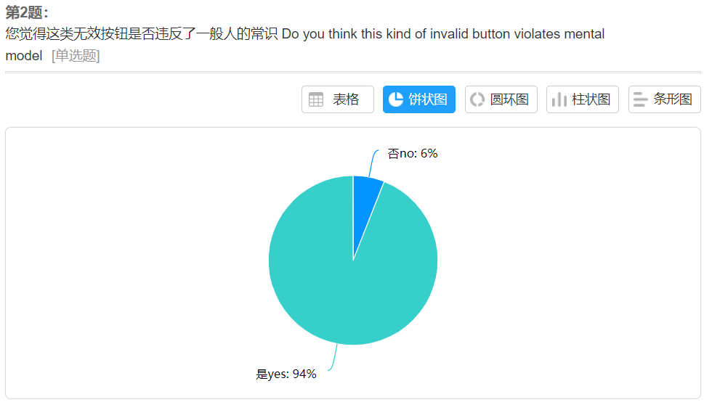

Fig.11. 94% surveyed user agree imaginary button against common sense

**3.1.3 File-uploading Function**

The DP of “provide feedback” [1] means product should provide feedback to users to make convenient on controlling. After the user submit a coursework, especially the large files, LM will not give feedback, so user cannot clearly know whether the file has been uploaded successfully or whether the submission has been completed. Therefore, this function violating the DP of “provide feedback”.

**3.2 Discussion on NetEase Cloud Music**

**3.2.1 Miscellaneous Unrelated Functions**

It violated DP of “Simple and natural dialog, mental model”. There are 69.47% people think that NEC-music contains unrelated information. People use the music applications mainly to listen to music, removing or hiding irrelevant or rarely needed information is exactly what the design should focus.

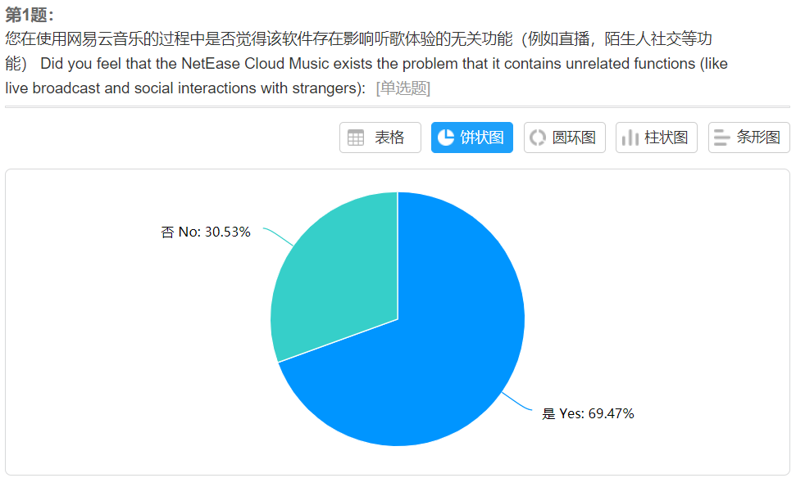

Fig.12. 69.47% surveyed user agree imaginary button against common sense

**3.2.2 Private FM Function**

There are two DPs that be violated in the function of private FM model. Since most of people think that if a song list can be traveled by execute operation of “swipe left”, they will instinctively try to traveled by execute operation of “swipe right”. However, the facts have greatly deviated from their expectations. Thus, 90.48% of users who think this design violates human’s common sense, which is an Intuitive proof for the violation of DP of “Simple and Natural Dialog, Motel mode”. Nevertheless, DP of “Does not Surprise the User” [4] is aim to make result of operation foreseeable, but 61.9% users conceded this problem “make them surprise”. User was not getting an expected result, so this problem violates the DP of “Does not Surprise the User” as well.

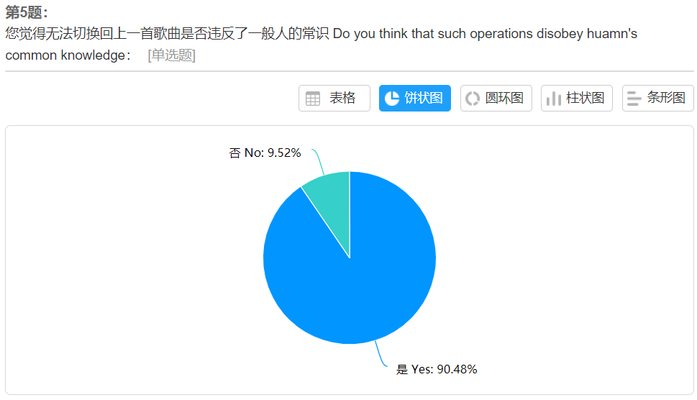 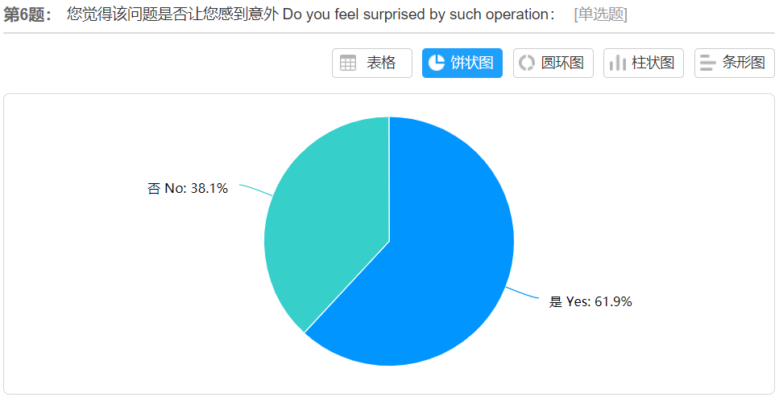

Fig.13. 90.48% surveyed user agree private FM model against common sense, and 61.9% surveyed user said they feel surprised

**3.2.3 Private Song List Function**

As is mentioned above, NEC-music can turn a private list into a public list, and turning the list can be viewed as an undo operation. Operations should to be reversible, which is the connotation of DP of “Provide undo and redo Functionality” [3]. As a result, the DP of “Provide undo and redo Functionality” is violated here, which is also agreed by 90.91% surveyed people. In addition, it violates the “Deal with Errors Positively: Provide Help” [5]. “Deal with Errors Positively: Provide Help” means that errors could happen at any time under any circumstance, so systems should provide meaningful messages to solve the errors. In some situations that the irreversible operation can be viewed as a type of error (or slip). Because the undo function is a possible way to deal with the error, removing this function is not the most efficient and possible way to avoid this error.

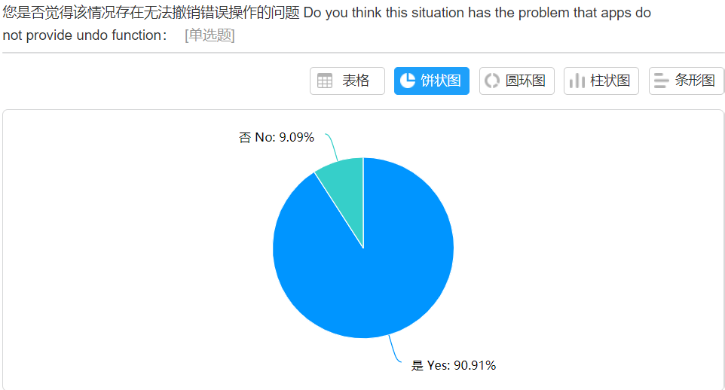

Fig.13. 90.91% surveyed user agree private song list do not provide undo function

**4. Conclusion**

**4.1 Conclusion of Learning Mall**

For the login function, webpage could hide the “log in” button if users had been logged, which will avoid confusion effectively. According to the statistical results, around 61.4% users think LM should jump to dashboard directly, and around 38.6% users advised that LM should move the “Dashboard” button to a more obvious place.

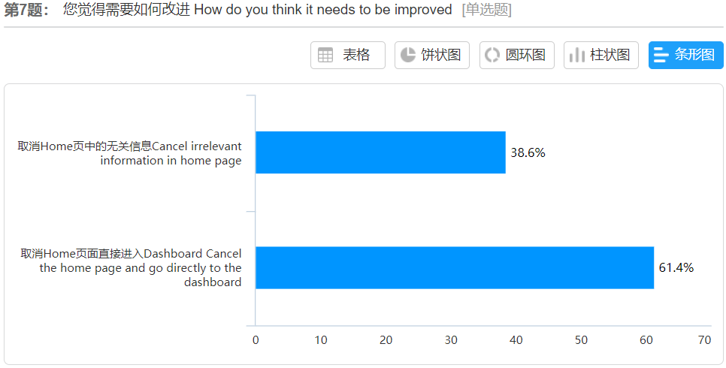

Fig.14. Statistical results of improving method of LM login interface

Moreover, for the “my course” problem, 38% students think such buttons should be deleted, and 60% people discuss that LM should use a real path instead of an imaginary button.

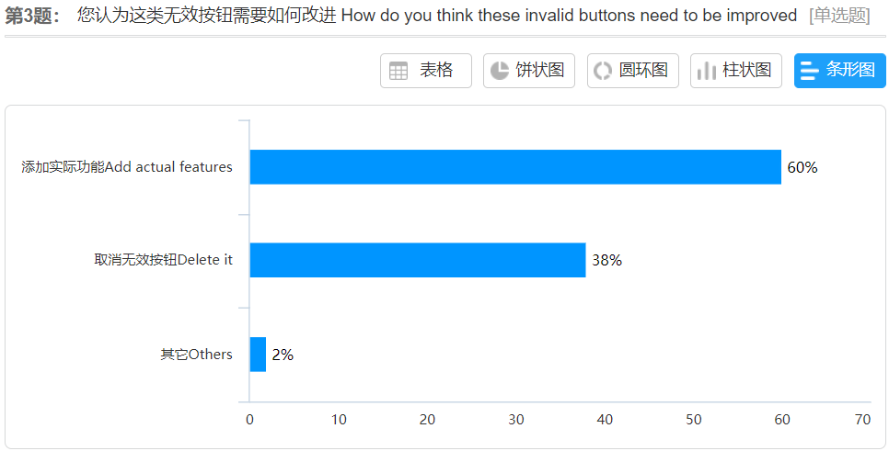

Fig.14. Statistical results of improving method of imaginary button of LM

Finally, according to the questionnaire survey, 54.17% people agree that adding a progress bar is a good solution meanwhile 45.83% people will be more likely to add "upload in progress" and "upload succeeded" signals.

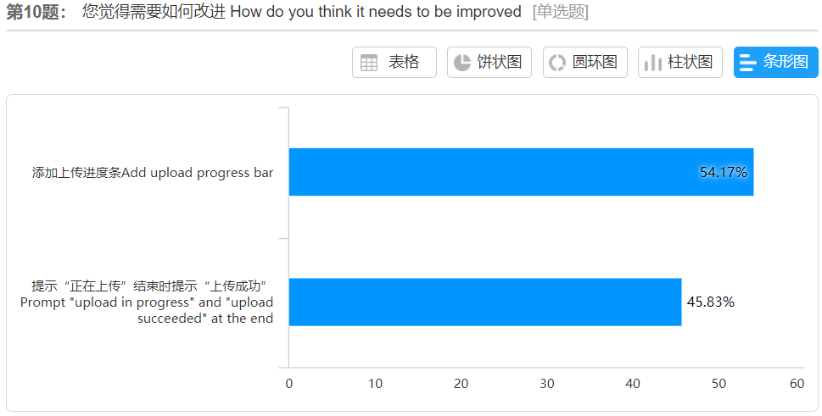

Fig.15. Statistical results of improving method of imaginary button of LM

**4.2 Conclusion of NetEase Cloud Music**

Firstly, based on the survey’s feedback, 68.18% people choose to maintain the unrelated functions but people can change the settings to hide them. 30.3% people would like to separate such functions. Only 1.52% participants recommend that simply deleting the functions is the best way.

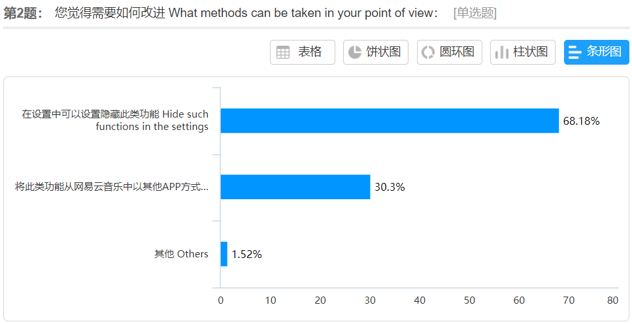

Fig.16. Statistical results of improving method of unrelated functions of NEC-music

In addition, 92.86% people would like to make changes that let the application has the feature represented below: changing the left button to previous button. While the left 7.14% people holding two different opinions. One is to remain the same without any changes because of the reason that they get accustomed to it, the other is to use another music application.

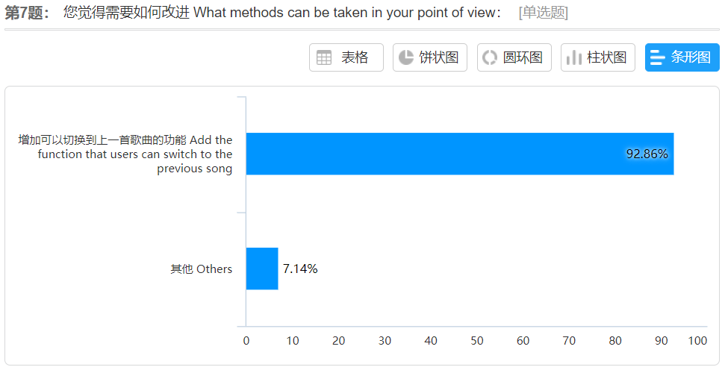 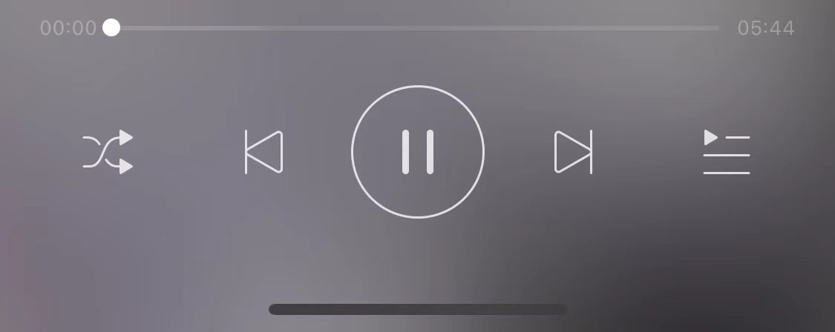

Fig.17. Statistical results of improving method and optimization diagram of private FM function of NEC-music

In the end, as is shown above that the most possible solution is to add logical and predictable undo functions. As all the students we investigated suggest that we should add similar functions to NEC-music, an optimization diagram is shown as below.

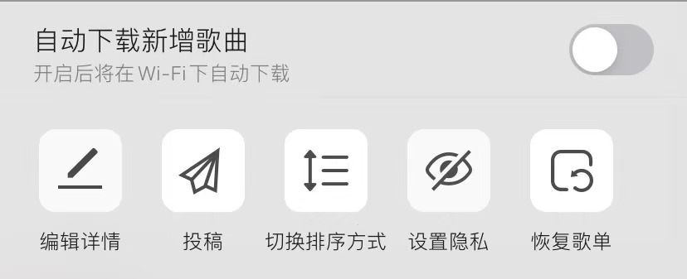 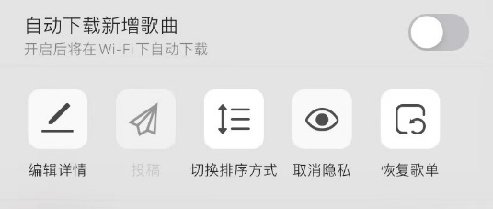

Fig.18. Optimization diagram of song list of NEC-music

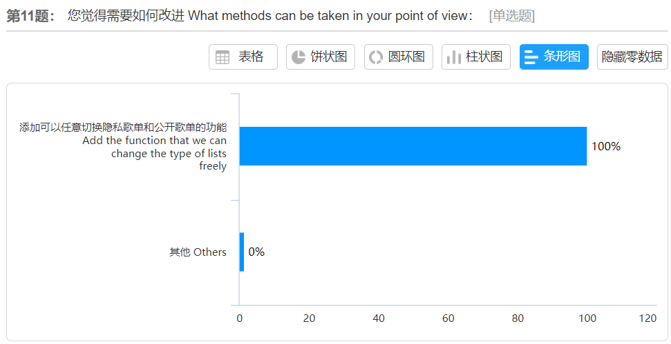

Fig.19. Statistical results of improving method of song list of NEC-music

**5. Reference:**

[1] Improving a human-computer dialogue https://dl.acm.org/doi/abs/10.1145/77481.77486

[2] A Brief Tutorial on the Development of Measures for Use in Survey Questionnaires https://journals.sagepub.com/doi/abs/10.1177/109442819800100106

[3] Chapter 5: Usability heuristics. Nielsen, J. (1993) In Usability Engineering, p115-163, Academic Press.

[4] Design guidelines for user-system interface software <https://apps.dtic.mil/sti/citations/ADA154907>

[5] Learning by doing with simulated intelligent help https://dl.acm.org/doi/abs/10.1145/48529.48531